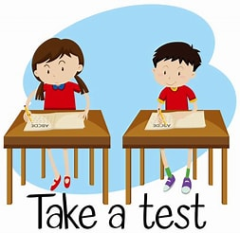

SATs

Sometimes we takes tests at school. That means we have to sit down at our tables and answer some questions about things our teacher has talked to us about in class.

When it's time to take my test, I will sit at my table and the teacher will give me some test papers to complete. Sometimes taking a test makes me nervous because I don't know if I will know the answers. It's okay to be nervous.

My friends in class might feel nervous too. It is important to try to be quiet while taking a test. During a test, I have to follow a “Be quiet. No talking to others” rule. Talking is not allowed during a test because it disturbs others from writing their test.

I can ask my teacher permission if I have to go to the toilet. But I should try my best to hurry back and finish my test.

If I am not able to answer a question, I will move to the next question so that I can finish the test on time. If my teacher or helper says it's time to stop writing, it's okay. I will stop and hand in my test papers to my teacher.